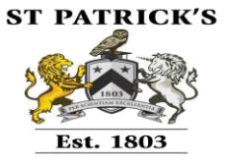

Student Name
Student ID
Assessor Name
Qualification | Pearson BTEC Level 5 HND Diploma Business
 | (Management)
Unit Number & Unit | Unit 32 BUSINESS STRATEGY
Title
Assignment Title
Date of Submission
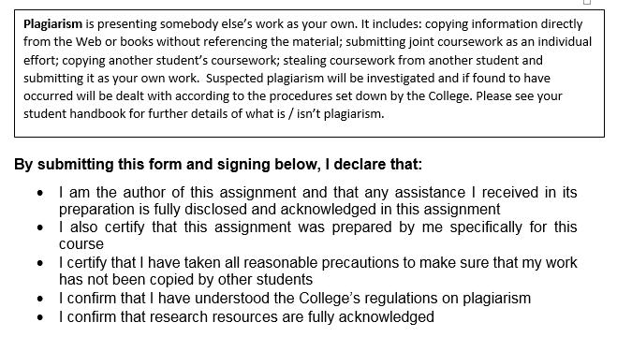

Signature: ……………… ……………………… Date: ___________________

1 | P a g e

Contents
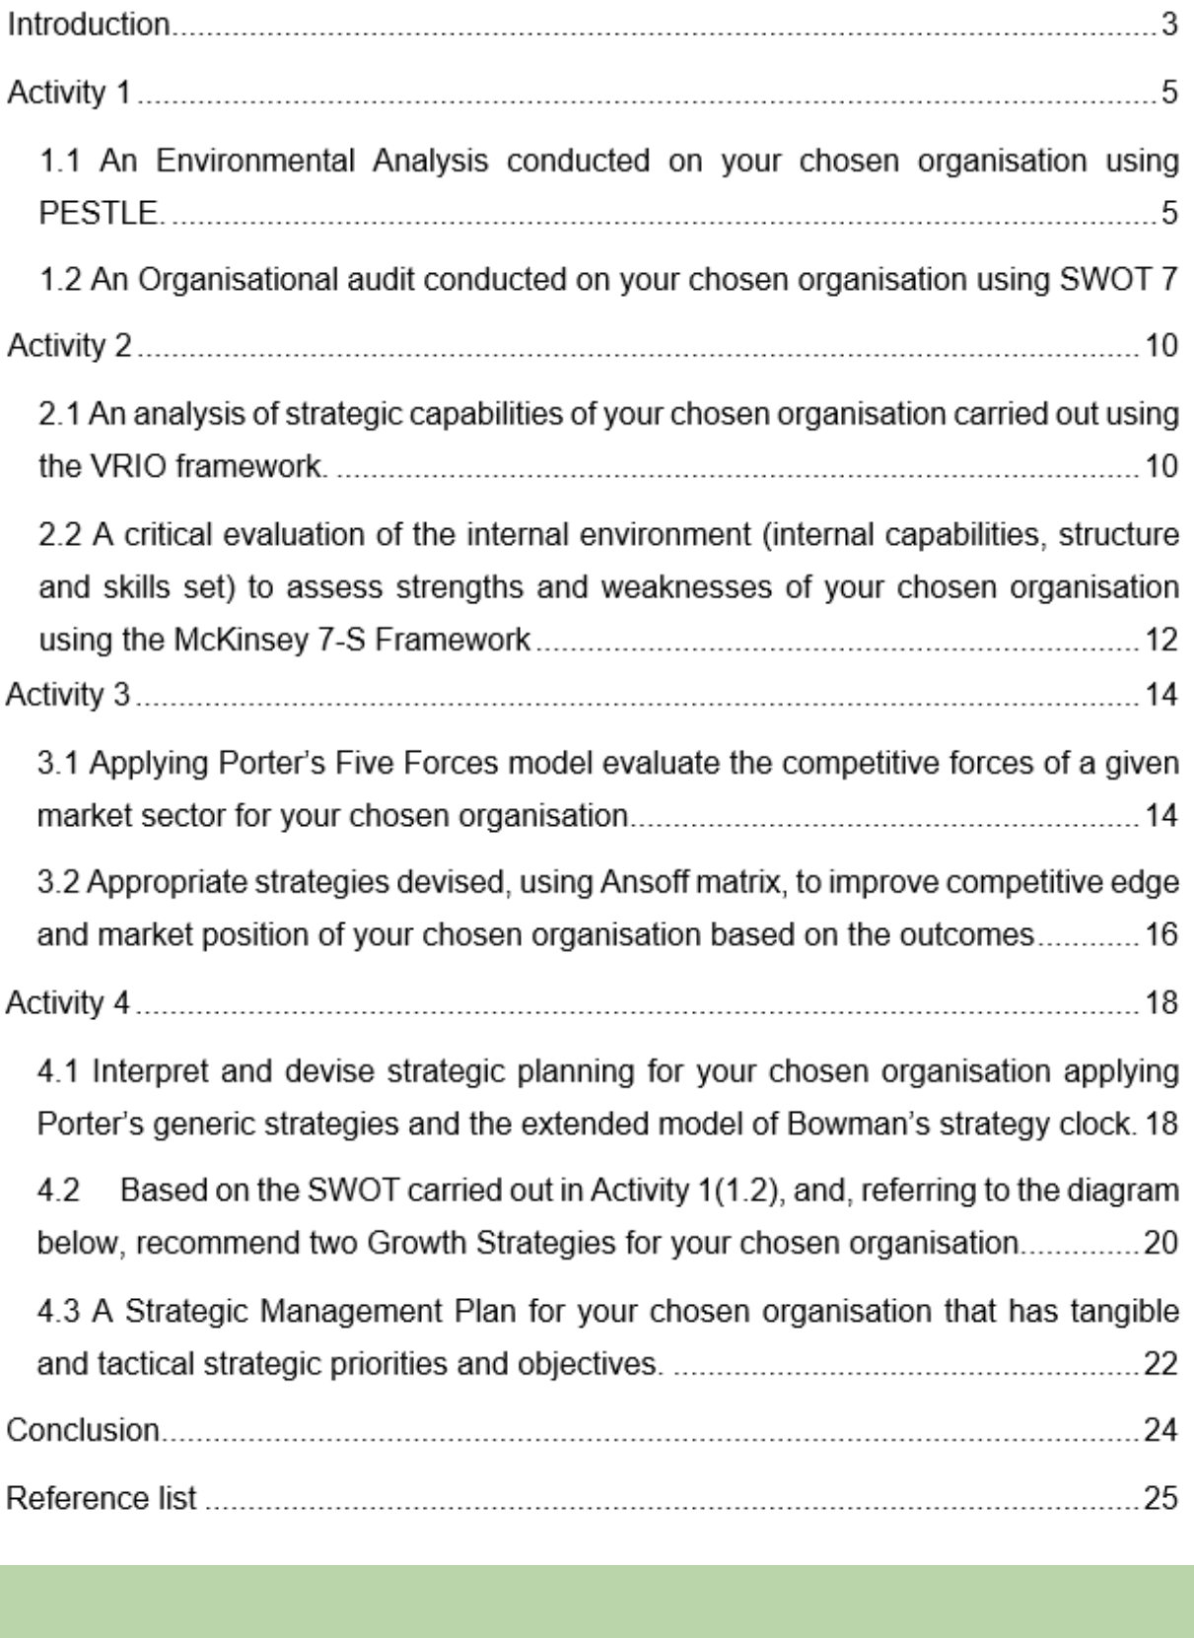

2 | P a g e

Introduction

A strategy is a pattern in which the applicant made actions with resources allocation to execute business operations effectively. Generally, strategy deals with the external competitive forces to produce the higher result from a project. A business firm strategy consists of a set of competitive actions and executive approaches that management adopts step by step to achieve business objectives. Under a strategic plan, three key elements that an organisation much follow. These include a purpose, organisational vision, and strategy. Purpose indicates a motive within the strategy. The vision indicates company business objectives and strategy is defined as an adaptive plan to achieve business objectives. A business strategy includes company mission and vision statement clearly so that management and employees can run their professional job based on mission and vision statements. This forces them to achieve business goals properly.

3 | P a g e

Overview of chosen organisation- Tesco Plc

Tesco is a British multinational groceries and merchandise retailer. It is the third-largest retailing company in the world grocery and merchandise industry. Tesco founded in 1919 as a limited company with small capital and manpower. Since the 19th century, Tesco enhances its operating area and product and service line in the UK market. Tesco controls its retailing business from Welwyn Garden City, Hertfordshire, England. Tesco operates its retailing service with a skilled storekeeper and technician. It has more than 450000 skilled and loyal employees in 2019. Tesco operates its business operation with 6800 shops and a strong distribution channel in England and Wales (Smith, 2010). Subsidiaries of Tesco Plc are Tesco store Ltd, Tesco family dining ltd, Jacks, Booker Group, Dunnhumby, Tesco Bank, Tesco Mobile, etc. The operating income in 2019 reaches above £2.206 billion with a new income of £1.320 billion which is larger than any other firm in England.
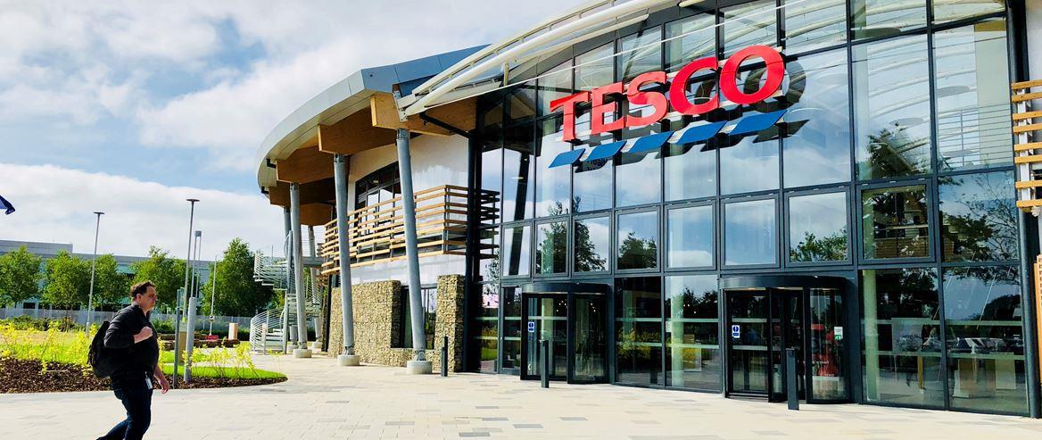

Source: Tesco retail shop in England (Smith, 2010)

4 | P a g e

Activity 1

1.1 An Environmental Analysis conducted on your chosen organisation using PESTLE.

Macro-environment

The macro-environment refers to external and uncontrollable influences that impact organisation business operation and decision-making power. It impacts on future performance and strategies which forces business function. The macro-environment includes economic factors, social, demographic, political, legal, environmental, and technological changes. Generally, macro-environment factors influence the following business factors including competitors, culture, norms, interest rate, weather, government policies, etc. An organisation requirement to consider these factors every time to develop a strategic business plan.

The COVID-19 outbreak restricts global business operations at present. From December 2019, the world faced COVID-19 pandemic and negative consequences. This various disappointment every sector from small to a multinational business firm. This pandemic situation changes business operation, distribution, and customer service system in over-night. It is hand to control such changes without significant changes in business strategy on production, distribution, and management team. Here we discussed the impact of COVID-19 and Tesco's strategic plan to handle these epidemic consequences (Munoz and Naqvi, 2020).

For COVID-19, some industry restricts their business operation as government imposes restriction and regulation upon them. This is sudden and none can predict such an epidemic situation in part. Hence, it is really hard to manage the business operation, profitability conditions, employees’ benefit, and wages payments. In the UK, more than 5 million people lost their jobs for the COVID-19 outbreak in the first secession of 2020. Economist threatens all industries businessman much and predicts that more than 20 million people will lose their job in the last session of this year.

Some industries like fast food, airlines, tourism, and travel, have not been able to manage their profitability condition. They forced to fire employees to reduce fixed costs.
5 | P a g e

The impact and influence of the macro-environment on Tesco retailing function:

To handle the negative consequences of COVID-19 outbreaks, an organisation need to analysis the macro environment to design a new business strategy. The PESTEL analysis especially scrutinizes the influences of environmental, social, political, economic, technological, and legal impact on business firms.
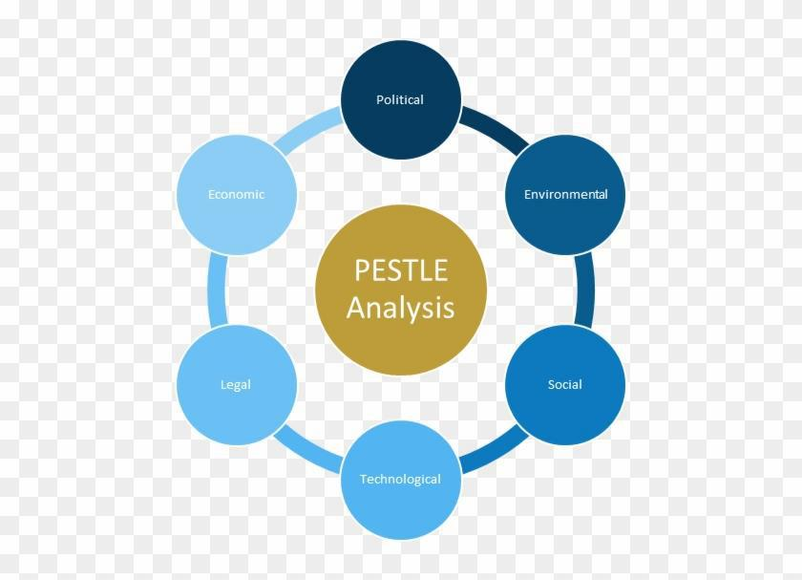

Figure: PESTLE analysis, Source: Evans, 2012

- Political- The Novel Coronavirus outbreak changes global politics, especially, USA and China engaged with new political conflict duo to COVID-19 outbreak origins misleading statement. American percent claimed that China's lab is responsible for spreading coronavirus in this human world. Contrary, China claimed that this coronavirus outbreak is natural and comes from the animal body. In summary, their conflicting statement restrict business operations very badly. In the future, anyone will and can impose hard and inflexible trade restrictions upon another. The political factors like tax policies, legislative bills, health and safety issue, import and export law, government stability impact negatively on business operation. Tesco needs to understand the global and national political environment to develop a business strategy.

6 | P a g e

- Economical- Economic factors like economic growth, inflation rate interest rate, the deposable income of customers, consumption rate, exchanges rate impact business policies, and operations. Due to the COVID-19 outbreak, global economic growth decreased an insignificant number. These factors impact Tesco's sales and product pricing strategy.

- Social- Socio-cultural factors like population growth, income distribution, age distribution, career attitudes, health, and safety consciousness impact Tesco's product and service operation. In 2020, people disposable income reduced due to COVID-19 impact, hence people's consumption reduced and the company loses sales volume. Customer attitudes and beliefs on Tesco products may reduce its acceptance (Evans, 2012).

- Technological- Technology play a significant role in this world to handle COVID-19 negative impact on the business industry. Telecommunication and technology-based companies like Facebook, and Micro-soft, disposable income in 2020 increased although the global business market reduced its income. Tesco should add technology infrastructure to develop communication with the customer, distribute produce through online marketing and distribution channel. Technological factors like intellectual property regulation, innovation, automation in service management, merging technology facilitate business operation.

- Legal- Legal factors such as health and safety law, trade law, advertising standards, product safety and quality law, consumer rights, opportunities law, etc. regulate business operation and strategic management function.

- Environmental- Tesco concerns environmental issues as their Corporate Social responsibility programme. This is important because the environment supplies raw material, manpower, and capital for business (Holbeche, 2015). Tesco handles environmental pollution by reducing air and water pollution, carbon emission.

PESTLE analysis help to take strategic plan on operation planning, organisational changes, business support, product and service development, customer service with marketing, and distribution system.

7 | P a g e

1.2 An Organisational audit conducted on your chosen organisation using SWOT

Tesco conducts more than 80 million shopping trips per week, in every second Tesco serves 66 clients and its earning is approximately £141,000 per minute. Tesco is the largest and most favourable shopping dealer in the UK market. Though Tesco has the biggest selling market in the UK, it faced some internal and external limitations. SWOT analysis explores internal strength and weakness, and determine external forces that impact Tesco retailing function.

SWOT Analysis:

Strengths of Tesco

- Biggest grocery retailer as compared to their sales volume in UK retailing industry

- Tesco has a leading market share

- Tesco delivered retailoring

service with a skilled professional in more than 6800 stores

- Diversity in product and service. For example, Tesco operates in bank, technology, groceries and merendas sector

- Superior position in technology uses. For example, Tesco sues the RFID barcode system to records, count, and promote sales volume (Holbeche, 2015).

Opportunities from external sources

- Tesco recently introduced a new business policy named Jacks business. It used to reduce their operating cost.

- Tesco takes joint venture

opportunities with local retailers for expending sales volume.

- Online shopping help to

overcome the COVID-19 pandemic situation.

- Emerging markets in developing countries open new opportunities to increase Tesco's business operation.

8 | P a g e

- Efficient networking through technology support
 | Weaknesses of Tesco |  |  |  |  |  | Threats from external sources
 | • | Tesco failed its operation in |  |  |  |  | • | Christmas |  | and | controversy- In
 |  | Japan and American due to |  |  |  |  |  | 2017, Tesco faced social bad
 |  | political and social impact. |  |  |  |  |  | impact |  | when | it | launches
 | • | Decreased |  | by | approximately |  |  | Christmas |  | programming |  |  | and
 |  | 9% of operating profit in 2018 |  |  |  |  |  | discount system.
 |  | due to their Brexit issue. |  |  |  |  | • Fake fame as a legal threat- In
 | • Faced |  | trail | and accounting |  |  |  | 2017, Tesco was accused of a
 |  | scandal in 2017. That time |  |  |  |  |  | false | and | misleading |  | customer
 |  | Tesco | prescribed |  |  | false |  | with fake fame and brand image
 |  | accounting |  | statements |  | for |  | for specific product marketing.
 |  | misleading profit margin.
 | • Tesco |  | offers |  | products | and | • | Brexit | referendum- |  |  | After | the
 |  | services at a high price and has |  |  |  |  |  | Brexit agreement, Tesco has to
 |  | not a low-cost effective |  |  |  |  |  | bear | excess |  | operating |  | and
 |  | strategy. |  |  |  |  |  | distribution costs in EU nations.
 | • | In 2018. Tesco engaged with |  |  |  |  | • The economic crisis in COVID-19
 |  | the Clubcard scheme without |  |  |  |  |  | epidemic session- Due to
 |  | giving prior notice to their |  |  |  |  |  | coronavirus effects Tesco |  |  |  |  | close
 |  | customer. |  |  |  |  |  | its street sales and promotion
 |  |  |  |  |  |  |  | programme. From now, there has
 |  |  |  |  |  |  |  | no | guarantee |  | for | further
 |  |  |  |  |  |  |  | development |  |  | in | Groceries
 |  |  |  |  |  |  |  | industry for competitive forces by
 |  |  |  |  |  |  |  | M&S, ASDA, Walmart.

The impact and influence of the macro-environment on Tesco Plc.

9 | P a g e

- Macro environment determines business external forces that can restrict or promote operation with sizeable impact (Mourdoukoutas, 2015).

- It reviews business strategies with political, social, technological, and environmental impact.

- Identify a possible solution for external impact or problem.

- Evaluate the risk and protective factors that impact Tesco's business operation badly.

- Analysis of PESTLE or SWOT gives clear overviews of Tesco's current position and future business trends.

- By utilising PESTLE analysis one can analyse the performance of the macro-environment under the positive and negative situations.

10 | P a g e

Activity 2

2.1 An analysis of strategic capabilities of your chosen organisation carried out using the VRIO framework.

Strategic capability:

Strategic capability refers to one’s strength over another with an identical feature. An organisation should have some Strategic capabilities which help to overcome external forces and impact. A Strategic capability includes three key elements such as

- Resources: A firm has tangible and intangible resources that include financial resources are current debt, current asset, equity, cash reserve, credit line, etc., physical resource are plant and equipment, shops, fixtures, inventories, etc., human resource are management, employees, technician, trainer, experience personnel, etc., intangible resource are brand name, patient, copyrights, information, etc.

- Competences: The term competences indicate technical skill, managerial experience, and specialist for strategy planning, etc.

- Balance of resources: It indicates project and operation activities and balances after completing the project.

11 | P a g e

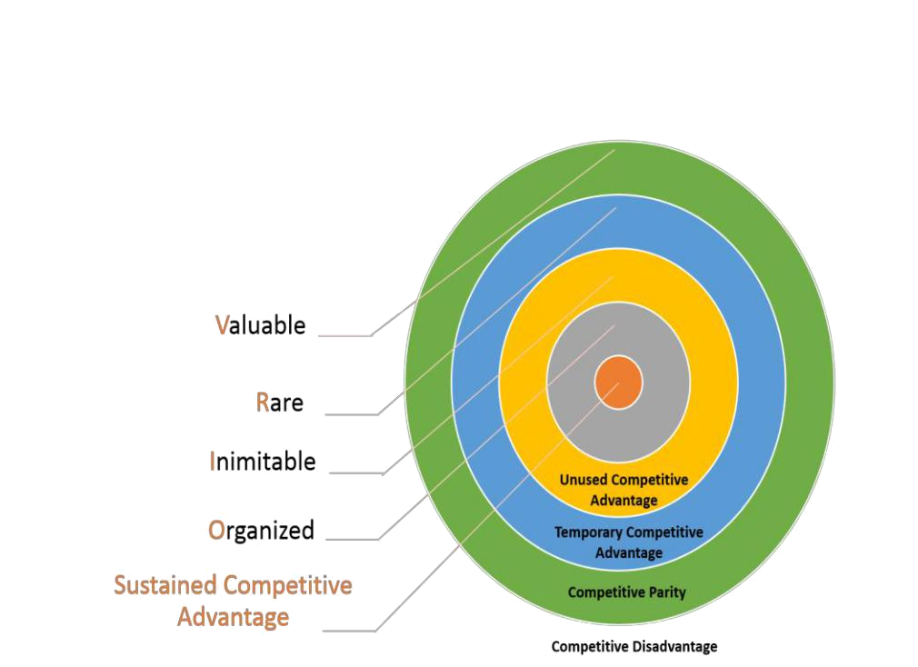

Figure & Source: VRIO framework (Johnson et al., 2015)

Analyse the strategic capabilities of Tesco Plc by using the VRIO framework

The VRIO framework is used as a strategic analytical tool for utilising company resources properly. It judges company capabilities and competitive advantage over competitors.

- Valuable: Tesco resource manager answered some questions like do its product generate a positive impression, are they able to explore competitive advantage, etc.

No- Company loses its competitive advantage. And need to refine its business strategy to develop their competitive advantage.

Yes- Go to the next step of VRIO analysis.

- Rare: Do businesses have enough control over scare resources? Do supplies enough for production?

No- Company faced resource rarity. And need to ensure supplies and a raw material alternative source for business operation (Johnson et al., 2015).
12 | P a g e

Yes- Company successfully identified its rarity, and go to the next stage of VRIO tools.

- Inimitable: Are supplies sources expensive? Is it difficult to control with another or alternative supplies?

No- When company resources passed value and rarity stage and failed in the inimitable stage, the company gets a competitive advantage temporarily. Tesco should go back to the previous stage and ensure reassess.

- Organised: Does the company have an organised leadership of management, culture, process, and operation system?

No- Company should promote its internal management with strategic structure. Design a leadership approach to control employees and operation channel.

Yes- When the company passes all the above stages of VRIO analysis, it will in full competitive advantage. The company has enough ability to handle external forces.

2.2 A critical evaluation of the internal environment (internal capabilities, structure and skills set) to assess strengths and weaknesses of your chosen organisation using the McKinsey 7-S Framework

Definition of McKinsey’s 7S framework

McKinsey’s 7S framework was developed by Tom Peter and Robert Waterman for achieving strategic fit in business operation. From its origin, this model is used for developing strategic planning (Bpp Learning Media., 2015). Now, the business organisation uses McKinsey’s 7S framework for identifying internal strengths and capabilities.

13 | P a g e

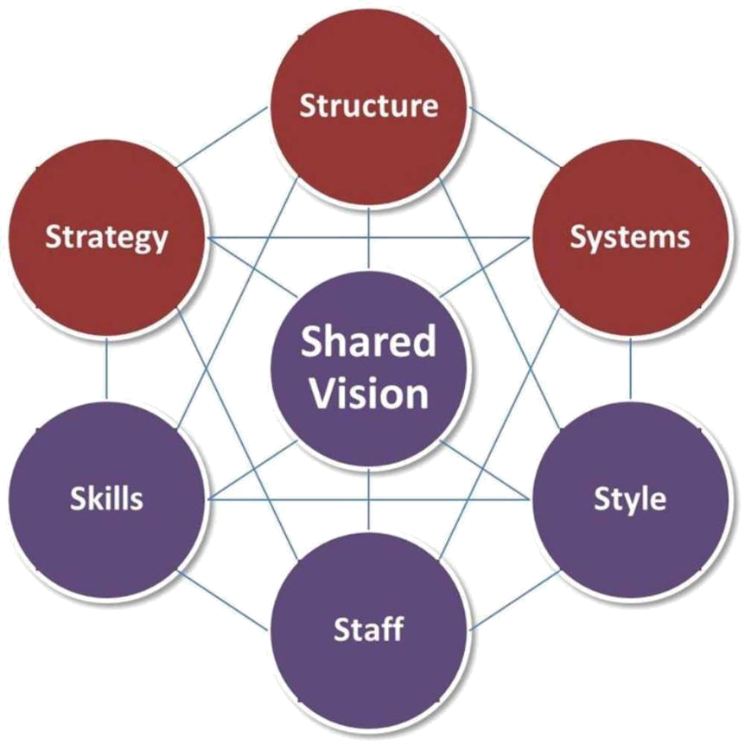

Figure & Source: McKinsey 7-S Framework (MOTOHASHI, 2016)

Evaluation of the internal environment of Tesco Plc using the McKinsey 7-S Framework

- Strategy: Strategy refers to an organisation plan for promoting competitive advantages in the global market. Tesco's strength includes brand image, skilled employee channel, large distribution in own shop, etc.

- Structure: This defines the management and leadership structure in which the company manages its business operation.

- Systems: It indicates the operational and distribution activities approach in which a business conducts its regular operation. Generally, Tesco uses a one-shop management process to handle its redialling function.

- Shared values: Company develop a workplace culture which forces firm goals. When an employee develops their beliefs and values upon the professional role, the firm achieved its business goals (Business strategy series, 2008).

14 | P a g e

- Style: It refers to management or leadership behaviour, norms, and culture in which they can control employee’s behaviour.

- Staff: It includes the professional channel within the firm, skill, and abilities required to accomplish the job, and benefits and privileges are offered in the workplace.

- Skills: Company needs specialist, technician, trainer to develop employee’s skills. Tesco has 450000 employees. They need technical and professional training to cope with competitive market changes. By confirming needed skill company can guarantee its core competencies.

The McKinsey 7s model is used for assessing business requirements to achieve a competitive advantage. These seven-element need to be united in such a way that improve overall business performance.

15 | P a g e

Activity 3

3.1 Applying Porter’s Five Forces model evaluate the competitive forces of a given market sector for your chosen organisation

Definition of Porter’s Five Forces Model

Porter’s Five Forces Model is an analytical tool that aids business managers for looking balance of power within the competitive market. This model analyses the attractiveness and market effectiveness with profitability condition. Porter's five forces model is used for understanding the company's strength, weakness, and competitive forces in the national or global market.
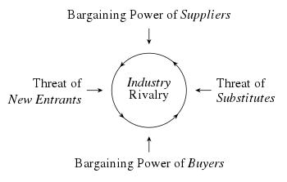

Figure & source: Porter’s Five Forces Model (Buckley, 2017)

An industry analysis of Porter’s Five Forces model of Tesco Plc

- Supplier bargaining power: Suppliers can drive the product price up at any time if they have such power or competitive strength. If any supplier rises its supply price, the company should switch cheaper alternatives if available. If not, the company cannot control its supply price.

- Buyer power: This indicates the power of customers. Customers can drive

down the produce prices if they have such power. When the market has a large

16 | P a g e

number of alternative products with the same feature and quality, the customer chooses the lowest priced product. Tesco should develop its innovation and product development for launching a new product with a unique feature.

- Competitive rivalry: This indicates market competitor number and their strength over the Tesco market position. Tesco uses an aggressive market strategy to increase profit margin. In the United Kingdom, the Retail industry has large and strong competitors like ASDA, Morrisons, Walmart, M&S, Sainsbury, etc.

- The threat of substitution: It indicates how easily a company customer finds out alternative products with the same benefits. A substitute product meets the same needs with the same feature and quality. If the market has enough substitute product, the company lose its power. Tesco has a large number of substitute competitor’s products (Focus on technology and processing, 2017).

- The threat of new entry: If a competitor easily entre your market, your company loses profit significantly. Technology advancement facilitates new entrants with experienced management and team.

Through Porter's five forces model analysis, Tesco's marketing manager can understand its buyer, supplier, competitor strength. If a company has the above-mentioned power, it should exercise. If it has not, the company needs to develop a business strategy to acquire these powers at any cost.

17 | P a g e

3.2 Appropriate strategies devised, using Ansoff matrix, to improve competitive edge and market position of your chosen organisation based on the outcomes

Definition of Ansoff Matrix

Ansoff Matrix is defined as a product or market expansion grid that analyse marker position and takes strategies for business growth.
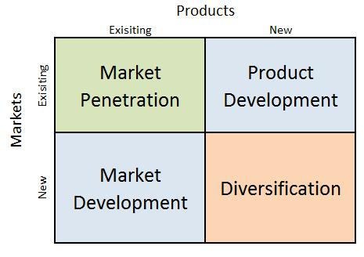

Figure & Source: Ansoff Matrix (Buckley, 2017)

Application of the Ansoff Matrix to devise an appropriate product/market strategy for

- Market penetration: The first strategy of the Ansoff Matrix is market penetration. It is a less risky approach where Tesco sells its present product into a standing market by adopting a new promotional strategy. This strategy is possible when the market is still growing its area (Focus on technology and processing, 2017).

- Market development: By using market development strategy Tesco promotes its existing product in new markets. Developing countries like India, Brazil, South Africa has a large market. Tesco can open a new shop or retail store in these developing countries with its existing offering.

18 | P a g e

- Product development: In that stage, Tesco invests much in innovation and development units for improving product features and quality that attract a new customer. For example, Tesco starts banking service with a retailing function that service different motives and customer in markets.

- Diversification: The final strategy of Ansoff Matrix is diversification. Here, Tesco target new customer with a new product. It is the riskiest and profitable strategy.

Evaluation of the suitability of the Ansoff Matrix strategies in the context of

Tesco plc:

Tesco can adopt all strategies for product or market development purposes. It is important to select which approach is suitable for where. Market penetration is suitable for increasing the existing market operation with existing production and distribution channel (Harvard business review on green business strategy, 2017). Market development is suitable if Tesco has excess cash in hand for investment. Product development is suitable for reducing the seasonal impact on the existing firm. Diversification is appropriate for exercising available expertise, technology, and global market support.

19 | P a g e

Activity 4

4.1 Interpret and devise strategic planning for your chosen organisation applying Porter’s generic strategies and the extended model of Bowman’s strategy clock.

Porter’s generic strategies

Porter’s generic strategies is a defined framework that is used for identification and evaluation of potential niche where the company can attain competitive advantage goals. It is also known as direction strategies.
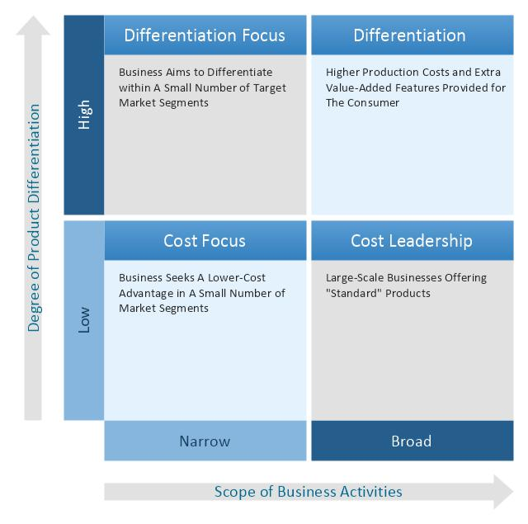

Graph & Source: Porter’s generic strategies (Savall, 2017)

Application of Porter’s strategy to Tesco plc.

Cost leadership strategy: The cost leadership strategy is concerned with operating and production costs that should be minimised to take a competitive advantage over

- competitor. 20 | P a g e

Differentiation leadership: This strategies force to make company products and service different from competitors. The R&D unit is concerned with product features, quality, support, durability that increase customers' value and acceptance.

Focus strategy: Tesco concentrates on a niche market where they invest more in achieving a one-side marketing controller. Tesco can adopt a franchise or joint venture strategy for promoting its focus market.

Differentiation focus: It involves marking company products unique, quality-based for targeting specific social class (Savall, 2017). Tesco uses new packaging, improved or new products for targeting new classes.

Explanation and application of Bowman’s Strategy Clock to devise strategic planning/strategic directions for Tesco plc:

Bowman’s Strategy Clock explores the strategic option for product proportioning. This model has two specific dimensions such as price and perceived value. With price and value-adding strategy, Bowman classifies this model into the following eight stages.

21 | P a g e

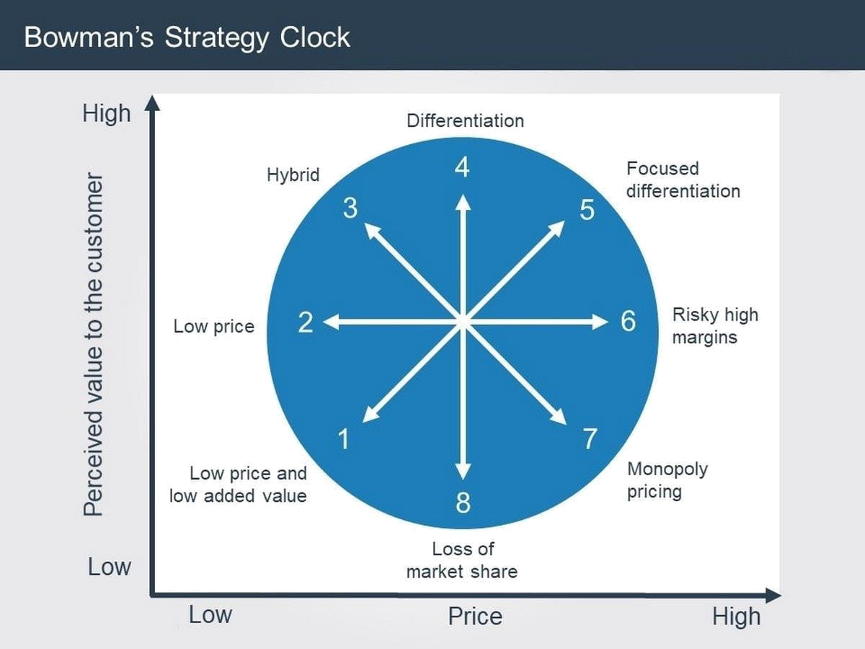

Figure & Source: Bowman’s Strategy Clock model (Park, 2018)

- Low Priced or Low Added Value: By keeping the product price as low as possible to attract a large community. This is an old model of business strategy.

- Low Price: Tesco offers low prices for attracting large community although it produces low-profit margins.

- Hybrid: If product development is consistent, a firm should use this strategy. Tesco can target different classes with a hybrid strategy.

- Differentiation: Here, Tesco focused on brand marketing apart from its quality development function (Park, 2018).

- Focused Differentiation: This strategy applies to a luxury product. Tesco uses target marketing, promotions, and distribution for luxurious goods in retail shops.

- Risky, High Margins: Here, Tesco changes its product prices in high with improved quality for gaining higher profit.

22 | P a g e

- Monopoly Pricing: It is not possible in the retail industry as there has a large number of competitors with similar goods and services.

- Loss of Market Share: Company may lose its market share if customers are not reluctant to buy its goods at a high price.

To handle the negative impact of losing market share, Tesco should set standard product price which is handy and reachable for all class.

4.2 Based on the SWOT carried out in Activity 1(1.2), and, referring to the diagram below, recommend two Growth Strategies for your chosen organisation.

Growth Strategy of Tesco Plc. (Justifications, and recommendation of these strategies)

An organisation needs to expand its market with substantial growth in respect to customer class, functions, and technology improvement (Munoz and Naqvi, 2018). A Growth Strategy increase market area, sales revenue, profit margin, and overall performance.

Limited growth strategies of Tesco plc.

Market penetration: The following guidelines are applicable when the firm wants to use market penetration-

- There has a large scope for marketing expansion

- The number of present customers may increase shortly

- Competitor market share may be reduced

- The company achieved economies of scale objectives

Product development: Tesco should use product development strategy when they get the following advantages-

- The existing product reaches its maturity stage,

- Major competitor offers the same or better-quality product with lower prices

- Have R&D capabilities

- Company compete with others in the high-growth market

23 | P a g e

Market development: Company uses an existing product for launching a business in new markets. For example, Tesco starts retailing shop in Oldham with existing clothes and foods. The following guidelines are applicable if a company goes the market development strategy-

- Gets new and reliable distribution channel

- Firm in successful trends and management have successful part records

- Have a human and technical resource to finance in a new market

- Have excess production and supplies capability

Substantive Growth Strategies for Tesco Plc., (Justifications, and recommendation of these strategies);

- Horizontal integration: The horizontal integration strategy includes the merger of acquisition that increases market share and control. Example of horizontal integration,

- Vertical integration: Tesco expands its operation back into the retail industry that offers input resources or forwards into a retail industry that distributes its product.

  - Backward: The firm seeks ownership or suppliers’ control by increasing market share in this industry. Example of backward integration, Tesco Plc. start a banking service in England.

  - Forward: This strategy increases control over firm distributor or retail shops. Tesco controls its 8600-retail store with forwards strategy. Example of forwarding integration, Tesco open a new distribution channel in Germany.

4.3 A Strategic Management Plan for your chosen organisation that has tangible and tactical strategic priorities and objectives.

A strategic management plan is a listed document that is used for coordinating and communicating organisation function to reach business goals. This plan includes superior priorities, specific business goals, focus energy, ensure resources, focus operation, employees, and stakeholder goals (Munoz and Naqvi, 2018). Generally, the

24 | P a g e

strategic management plan aligned employees and organisation goals ineffective way that results in higher output.

Justification of this Strategic Plan will be used to implement the recommended strategies in 4.2

The following strategic plan will applicable in Tesco retailing function. Tesco uses limited and substantial growth strategies for promoting its business operation in existing and new markets. A timescale regarding market expansion and developing strategy will help to excavate, control, and revise projected plans effectively. Tesco uses a Gantt chart for scheduling its market and product development project with sizeable investment. The following strategic plan justifies Tesco's substantial growth.

Strategic Management Plan:

 | Aim |  |  | Objectives | Allocatio |  | Target | Review | Deviation | Revised
 |  |  |  |  | n | of | Dates/tim | dates/ | diagnosis | target dates
 |  |  |  |  | Resource |  | escales | review | and | if applicable
 |  |  |  |  | s |  |  | point | corrective
 |  |  |  |  |  |  |  |  | action
 |  |  |  |  |  |  |  |  | dates
 | 1) | increased |  | Market | £160 |  | January, | July, | Oct, 2021 | Dec, 2021
 | market share |  |  | penetration | million |  | 2021 | 2021
 |  |  |  | goals
 | 2) | offered | quality- | Product | £100 |  | January, | July, | Oct, 2021 | Dec, 2021
 | based product |  |  | development | million |  | 2021 | 2021
 |  |  |  | goals
 | 3) | target | new | Market | £128 |  | January, | July, | Oct, 2021 | Dec, 2021
 | market |  | for | development | million |  | 2021 | 2021
 | promotion |  |  | goals
 | 4) | increase |  | Vertical | £105 |  | January, | July, | Oct, 2021 | Dec, 2021
 | controlling |  | power | integration | million |  | 2021 | 2021
 | over suppliers and
 | distributors
 | 5) | increased |  | Horizontal | £120 |  | January, | July, | Oct, 2021 | Dec, 2021
 | market share and |  |  | integration | million |  | 2021 | 2021
 | competencies with

25 | P a g e

merger and

acquisition

26 | P a g e

Conclusion

A business strategy is a planned document that listed business mission, vision, aims, management and leadership structure, production, and distribution approach. It enables a firm to reach its ultimate business goals with the strategic path. We know, no one can get its ultimate result in a simple way. Every firm has some natural weaknesses. Sometimes macro-environmental factors reduce company strength, increase weaknesses, and offer external threats. Strategy looks at these external threats, made a new plan and way to handle such risk. Business strategy is related to market research, decision thinking, and strategy making function. This assignment produces a clear overview of market forces and management working to reach its core competencies. Every company needs strategic plan to create a competitive advantage.

27 | P a g e

Reference list

2007. Harvard Business Review On Green Business Strategy. Boston:

Harvard Business School Pub.

2008. Business Strategy Series. [Bradford, England]: Emerald.

Bpp Learning Media., 2015. Business Essentials Business Strategy. [Place of publication not identified]: Bpp Learning Media.

Buckley, P., 2017. International Business. London: Taylor and Francis.

Evans, N., 2012. Extending The Radar. Upper Saddle River, NJ: Financial Times Prentice Hall.

Holbeche, L., 2015. Aligning Human Resources And Business Strategy.

[Place of publication not identified]: Routledge.

Johnson, G., Whittington, R., Scholes, K., Angwin, D., Regnér, P. and Pyle, S., 2015. Exploring Strategy.

Mack, C., 2011. Business Strategy For An Era Of Political Change.

Westport, Conn.: Quorum Books.

MOTOHASHI, K., 2016. GLOBAL BUSINESS STRATEGY. [Place of publication not identified]: SPRINGER Verlag, JAPAN.

Mourdoukoutas, P., 2015. Business Strategy In A Semiglobal Economy.

Armonk: Taylor and Francis.

Munoz, J. and Naqvi, A., 2018. Business Strategy In The Artificial Intelligence Economy. New York: Business Expert Press.

Park, Y., 2018. Business Architecture Strategy And Platform-Based

Ecosystems. Singapore: Springer.

Savall, H., 2017. Strategic Engineering Of The Reed. Charlotte, NC:

Information Age Publishing.

Smith, J. 2010. Business Strategy. Cambridge (Mass.): Basil Blackwell.

28 | P a g e

